How To Use GITHUB

Revision History
*A – Added, M – Modified, D - Deleted
Version | Date | A*, M, D | Change Description | Author | Approved By
1.0 | 16.Dec.2011 | A | Create new | Nguyễn Xuân Hoàng | Lê Văn Lập - IT Manager

Table of Contents
How To Use GITHUB 1
Table of Contents 3
1 About GitHub: 4
2 Setup Git: 6
3 Setup Working Directory: 6
3.1 Clone: 6
3.2 Add,Commit and Push: 8
3.3 Fetch and Pull: 12
3.4 Branch: 13
4 Reference: 16

About GitHub:
GitHub is a web-based hosting service for software development projects that use the Git revision control system. GitHub offers both commercial plans and free accounts for open source projects. According to the Git User's Survey in 2009, GitHub is the most popular Git hosting site.
Git diagram:
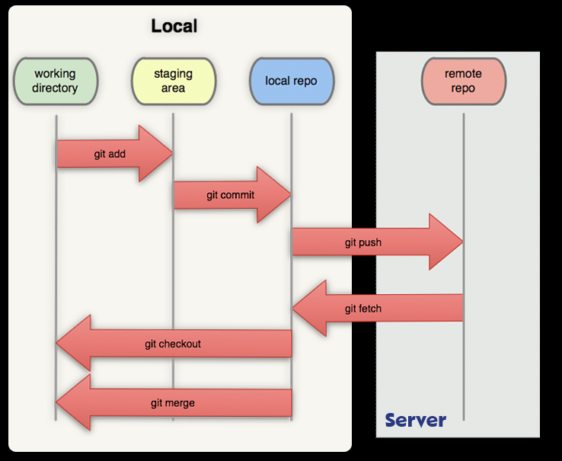

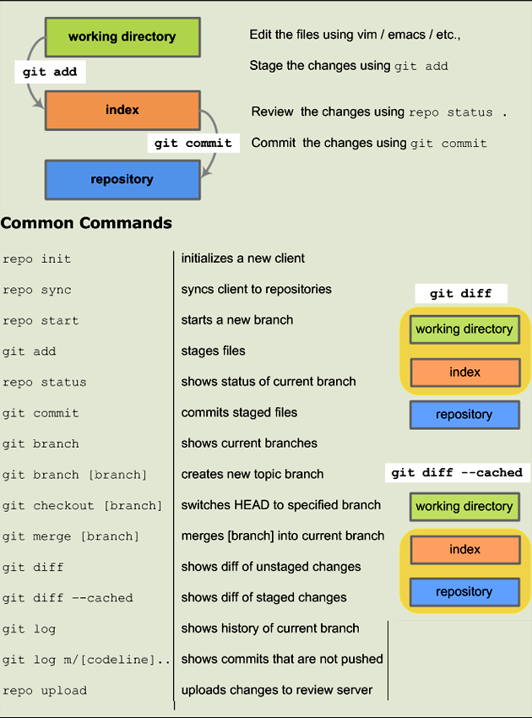

Setup Git:
Follow this link to know how to setup Git software in your PC . Because we use SSH keys to establish a secure connection between your computer and GitHub, please read carefully to create it: http://help.github.com/set-up-git-redirect/ . After that, we import public key to GitHub server to connect it.
We must install TortoiseGit ( http://code.google.com/p/tortoisegit/downloads/list ) to do all step by step below.

Setup Working Directory:

Clone:
We create a new Directory to clone new source on Server Github to this.
Right click to new Directory, select Git Clone:
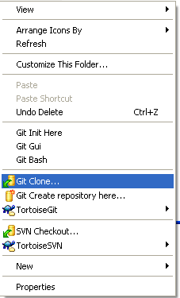

Fill in URL box with URL of our project on GitHub ( ex: git@github.com:clickataxi/android ).
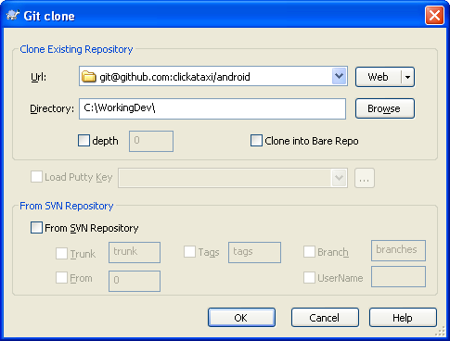

Press Close when it done.
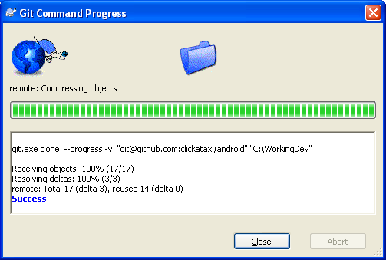
After clone, our folder code WorkingDev had a new hidden folder .git :
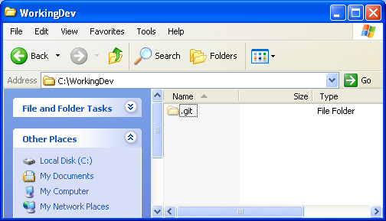

Add,Commit and Push:
When we created new file to Working-space, we will add to Git:
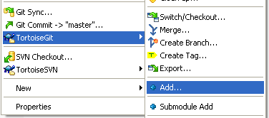
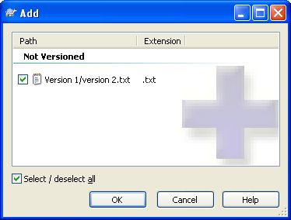

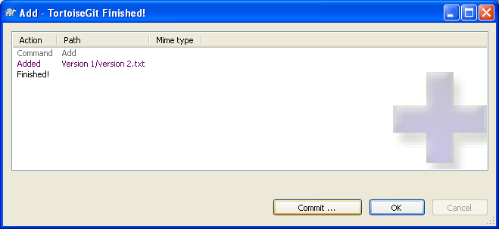
When we edited source code in our Working-space, Add or Delete file, we will commit all changed :
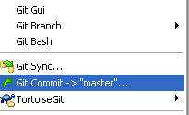
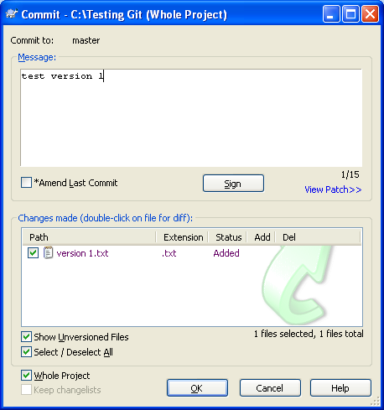
Maybe appear dialog error:
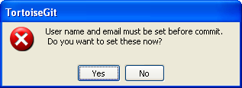
Click Yes to set username and email to setting of Git:
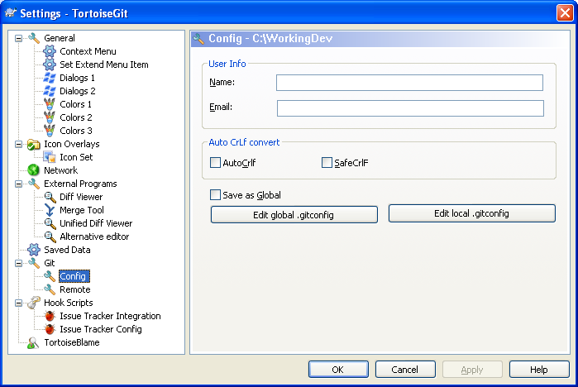
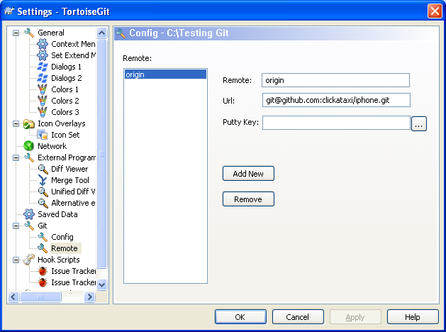
After that , we can push to public our code to GitHub server:
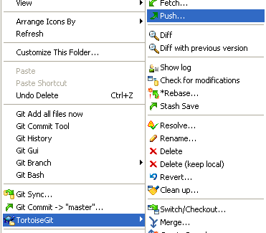
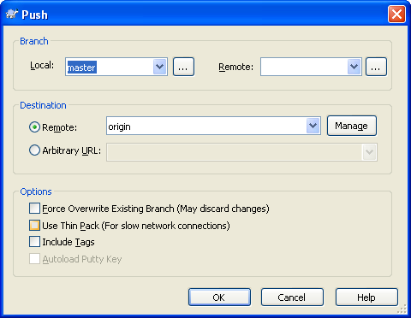

Fetch and Pull:
Fetch and Pull are used when we need update source from GitHub server to our Working-Space:
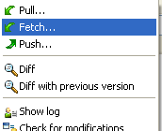
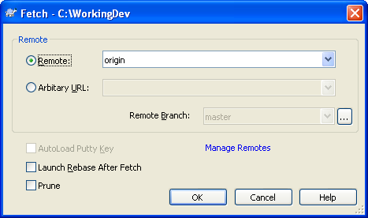
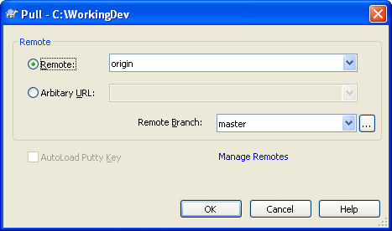

Branch:
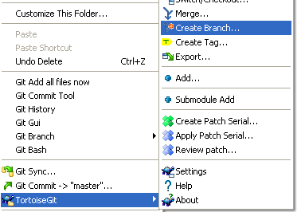
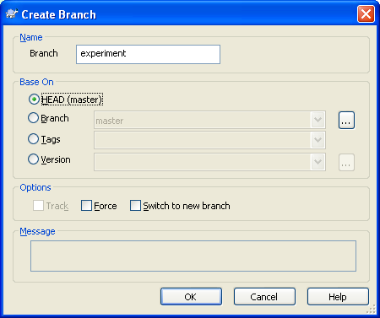
We must Switch to new Branch has created.

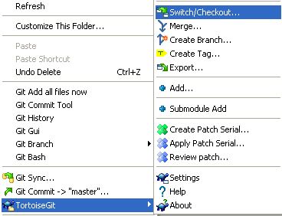

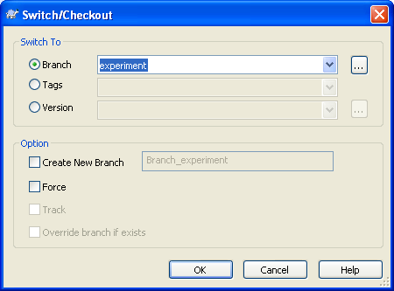
Or:
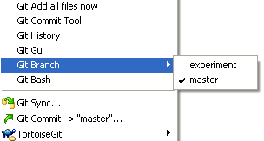

When we were finished projects on branch, we can merge branch to master.
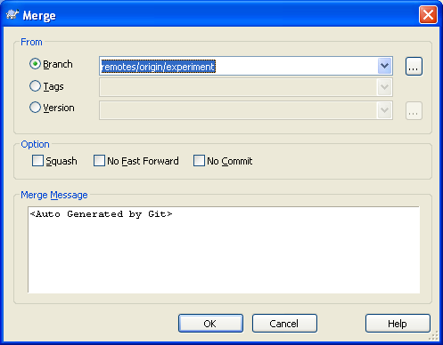

Always remember commit and push to public all changed to GitHub server.

Reference:
- http://help.github.com/set-up-git-redirect/
- http://learn.github.com/p/branching
- http://dientu5.org/forum/index.php?topic=154.0

